Provisining

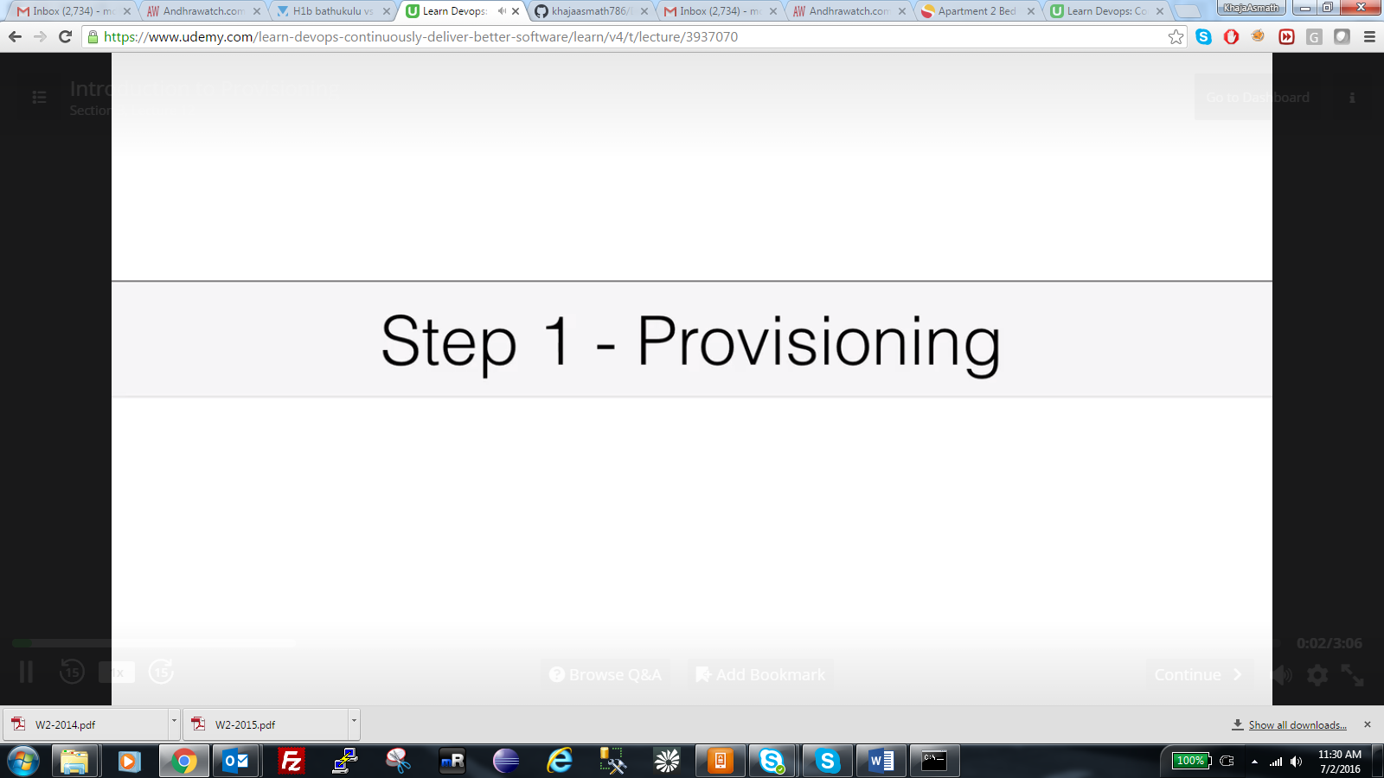

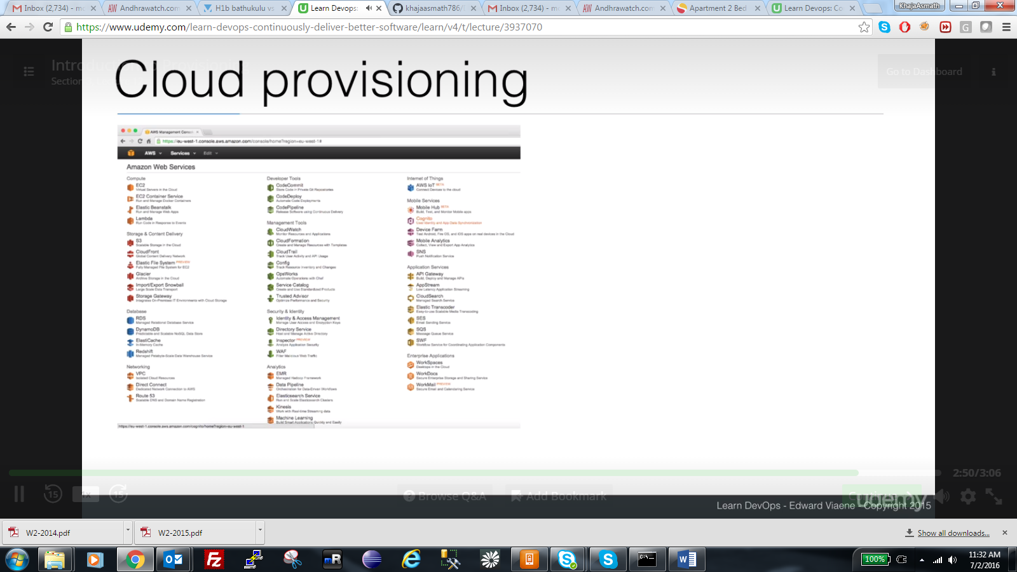

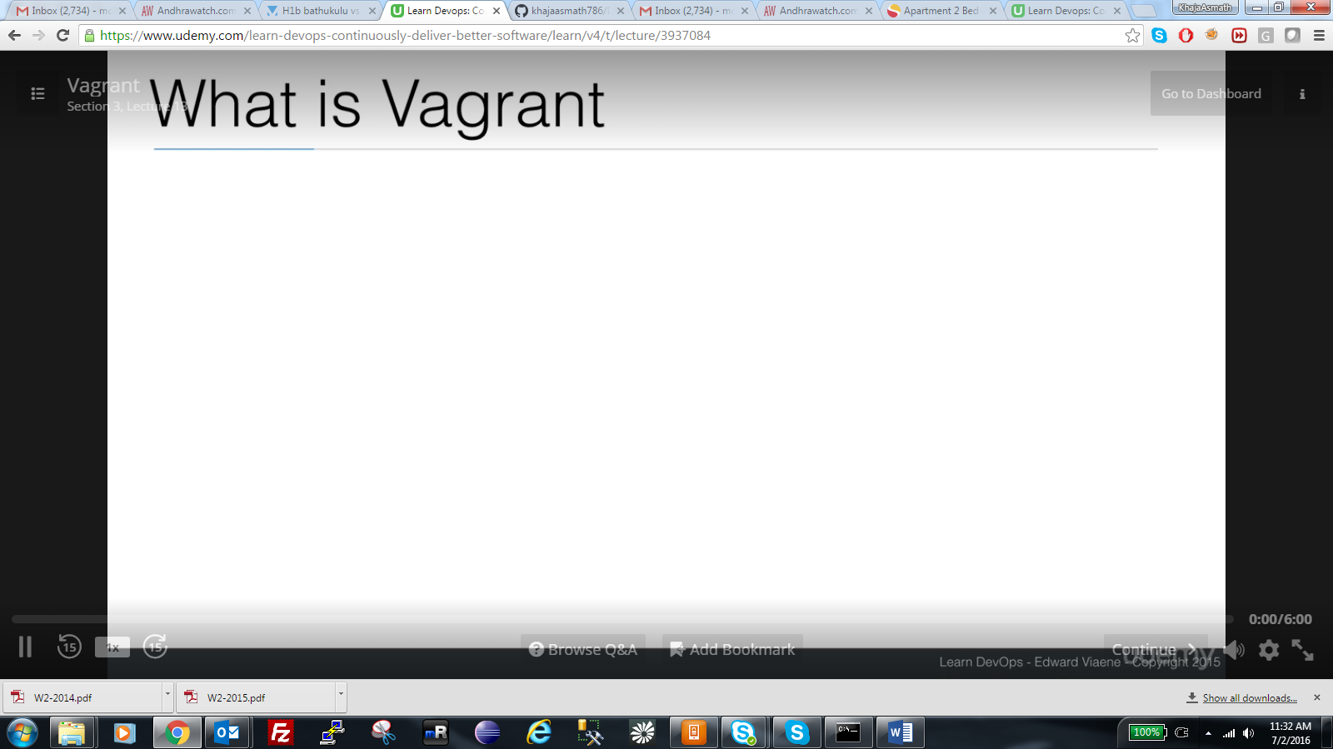

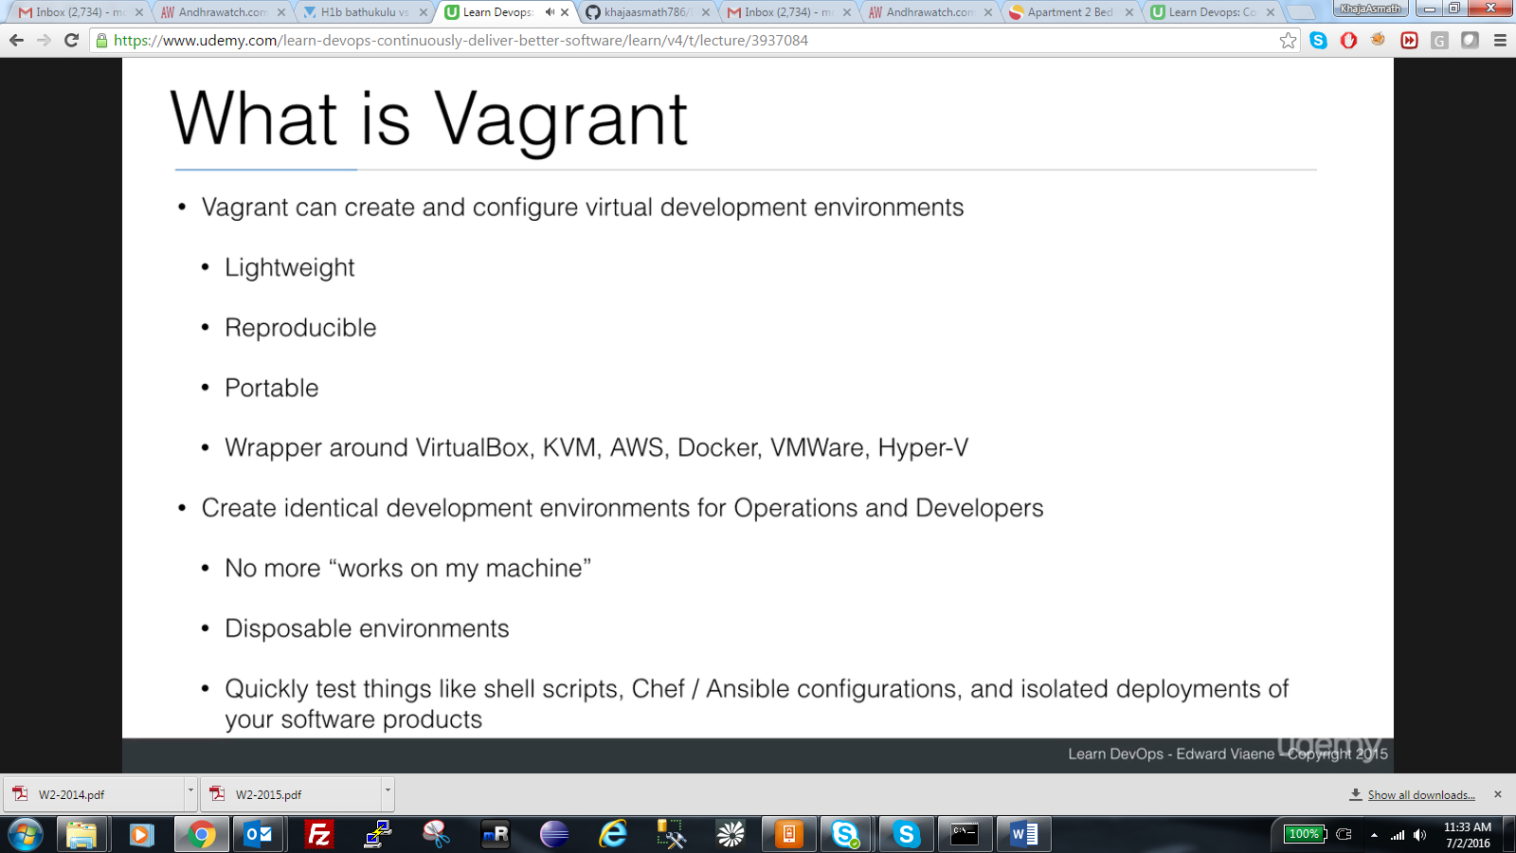

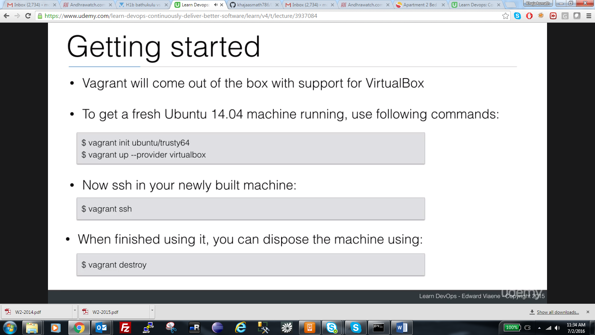

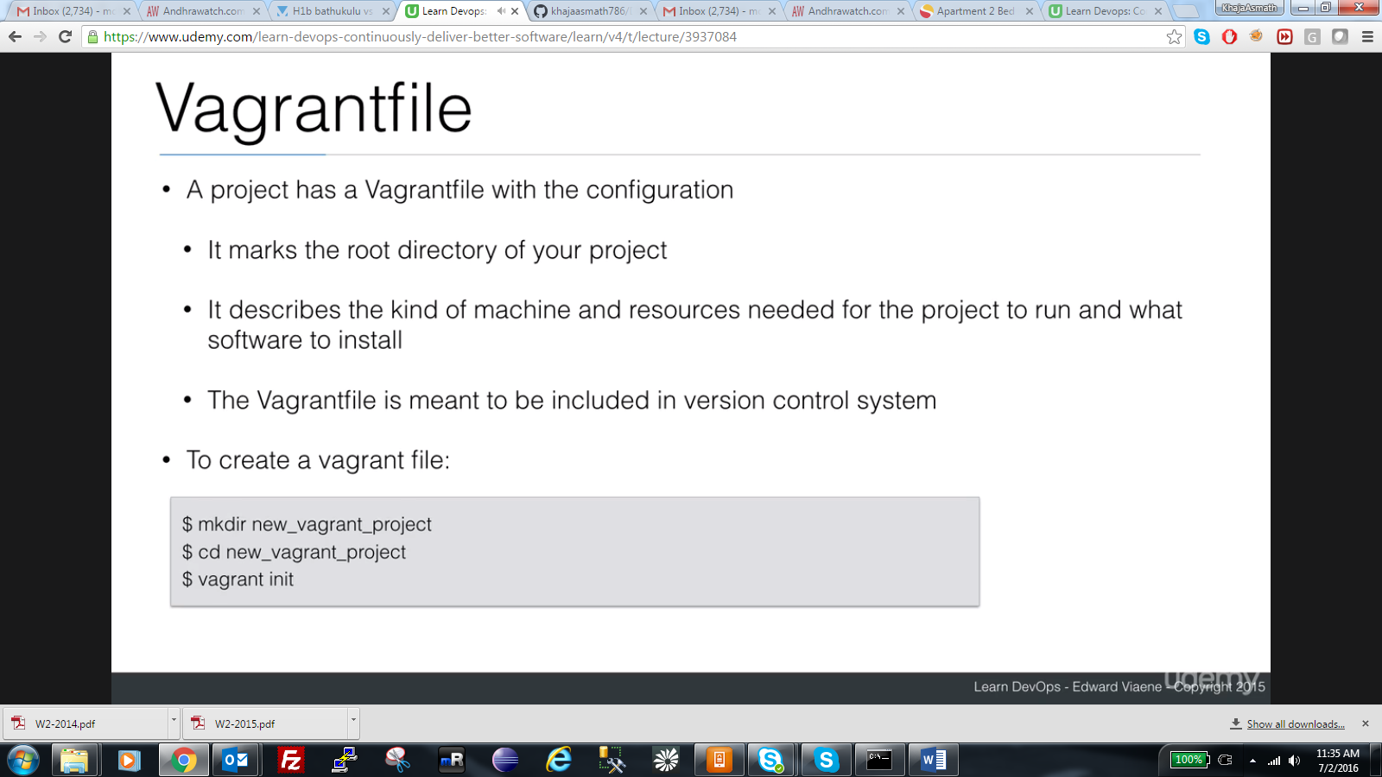

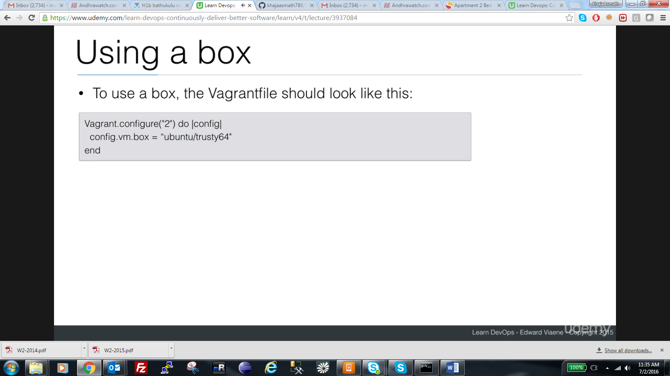

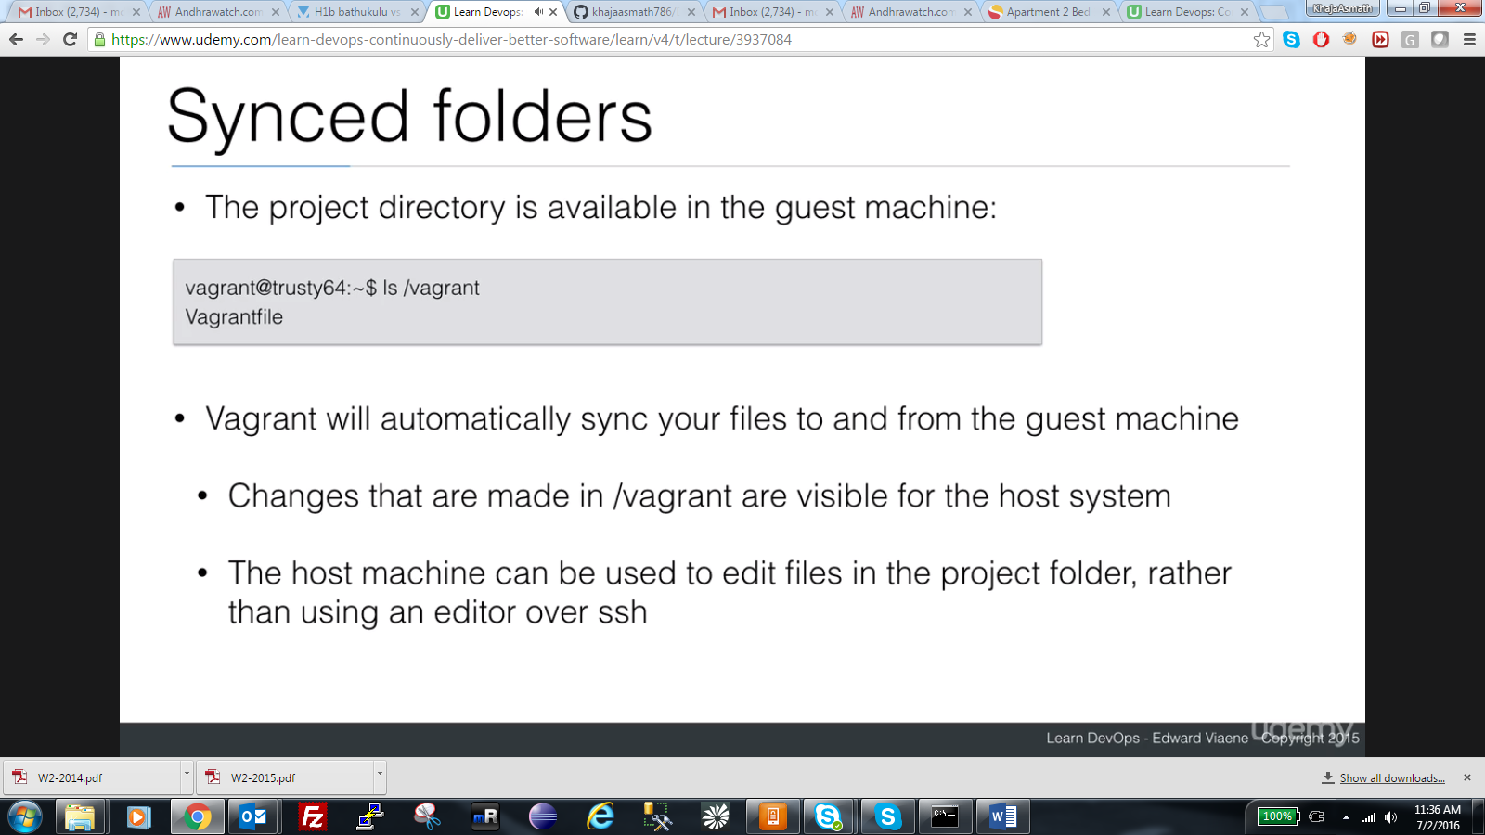

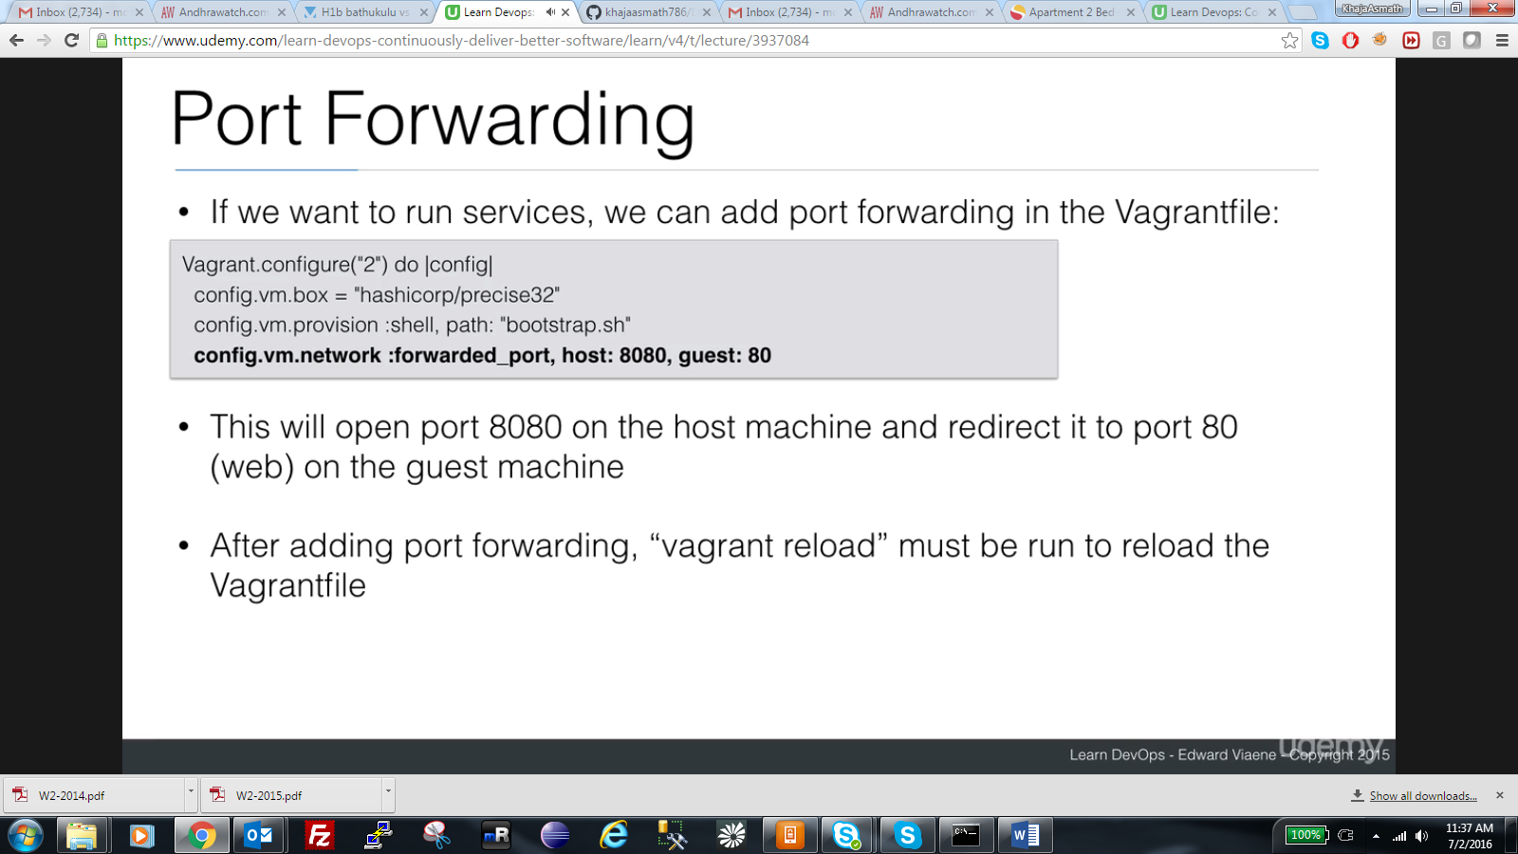

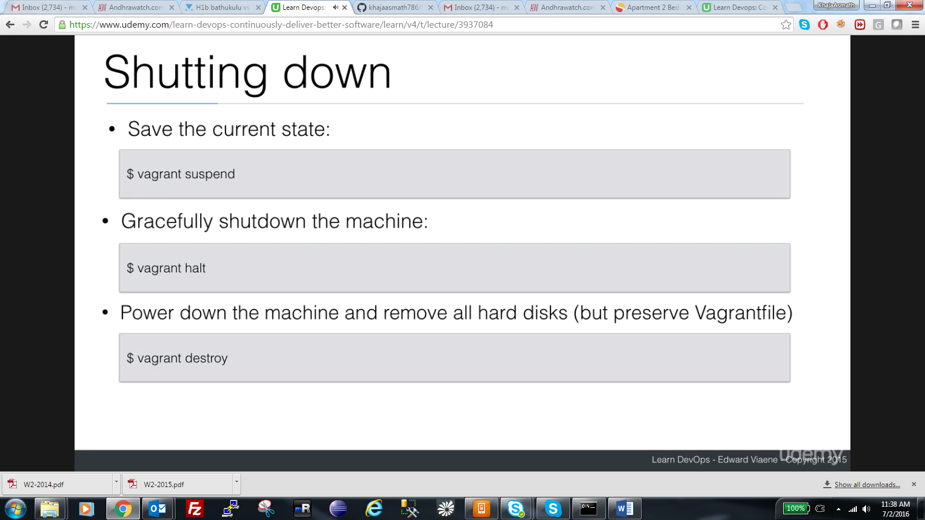

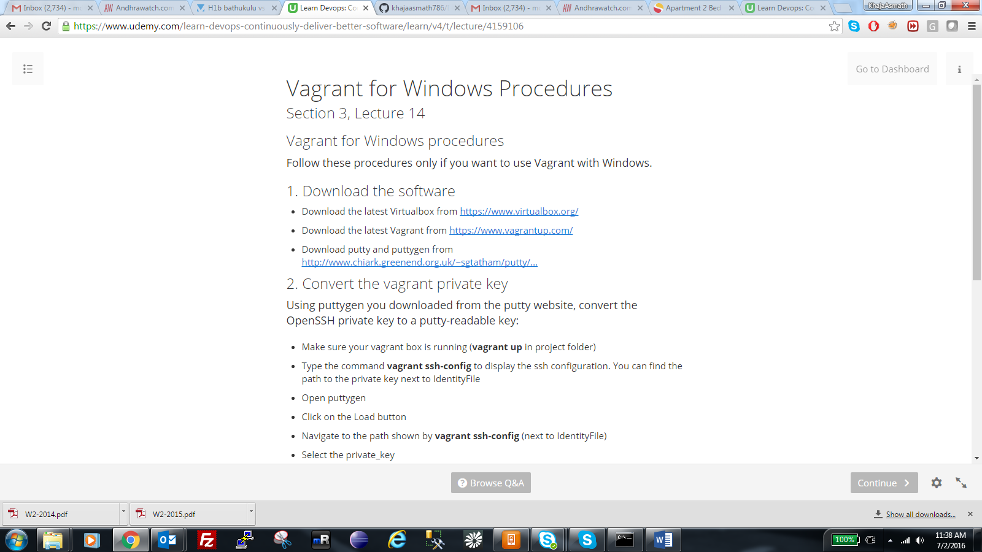

Vagrant for Windows Procedures—Follow Asmath Instructions

Section 3, Lecture 14

Vagrant for Windows procedures

Follow these procedures only if you want to use Vagrant with Windows.

1. Download the software

* Download the latest Virtualbox from <https://www.virtualbox.org/>
* Download the latest Vagrant from <https://www.vagrantup.com/>
* Download putty and puttygen from[http://www.chiark.greenend.org.uk/~sgtatham/putty/...](http://www.chiark.greenend.org.uk/~sgtatham/putty/download.html)

2. Convert the vagrant private key

Using puttygen you downloaded from the putty website, convert the OpenSSH private key to a putty-readable key:

* Make sure your vagrant box is running (**vagrant up** in project folder)
* Type the command **vagrant ssh-config**to display the ssh configuration. You can find the path to the private key next to IdentityFile
* Open puttygen
* Click on the Load button
* Navigate to the path shown by **vagrant ssh-config**(next to IdentityFile)
* Select the private_key
* Now click on the “Save private key” button and save the file as .ppk file somewhere where you can easily find it

3. Use putty to log into your Vagrant machines

Open putty and configure the following parameters:

* Session:
  + Host: 127.0.0.1
  + Port: 2222 and up (depends on how many vagrant machines you launch)
* Connection
  + Data
    - Auto-login username: vagrant
* Connection/SSH
  + Auth
    - Private key file for authentication: Click on browse and select your ppk file
* Session
  + Save the session to save the parameters you just entered

4. Alternatives

* You can also use the login/password combination “vagrant” / “vagrant”, but then you will have to enter it manually every time
* When configuring vagrant in the next lectures, I’ll often use a private IP address. You can use this private IP address with port 22 instead of 127.0.0.1:2222

**Follow Asmath Instructions below**

* **mkdir vagrantproject**
* **cd vagrantproject**
* **vagrant init ubuntu/trusty64**
* **vagrant up**

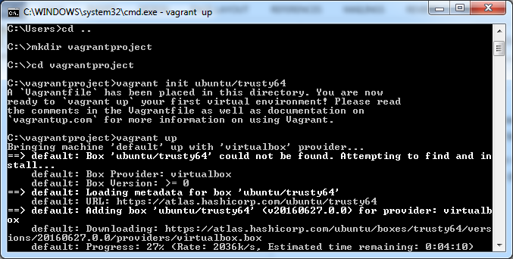

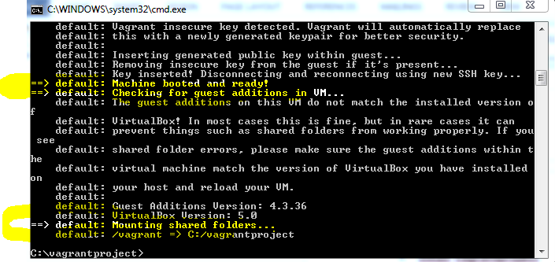

* **vagrant ssh-config (this wil give path of ssh kep that you can use with putty gen). follow windows instructions as shown above.**

**C:/vagrantproject/.vagrant/machines/default/virtualbox/private_key**

You cannot directly import with that file name instead manullay go that folder and generate PPK key

Save the file with puttygen as ppk in desktop.

**\*\*\*\*\*\*\*\*\*\*\* NOTE: When you use PUTTY vagrant should always be up and running like vigrant up or else you cannot access the machine \*\*\*\*\*\*\*\*\*\*\*\*\*\*\*\*\*\*\*\*\*\*\*\*\*\*\*\*\*\*\*\*\***

Open putty and configure the following parameters:

* Session:
  + Host: 127.0.0.1
  + Port: 2222 and up (depends on how many vagrant machines you launch)
* Connection
  + Data
    - Auto-login username: vagrant
* Connection/SSH
  + Auth
    - Private key file for authentication: Click on browse and select your ppk file
* Session
  + Save the session to save the parameters you just entered